Student ID: 103475009

Name: MAX BARRAH

# Setup Screenshot

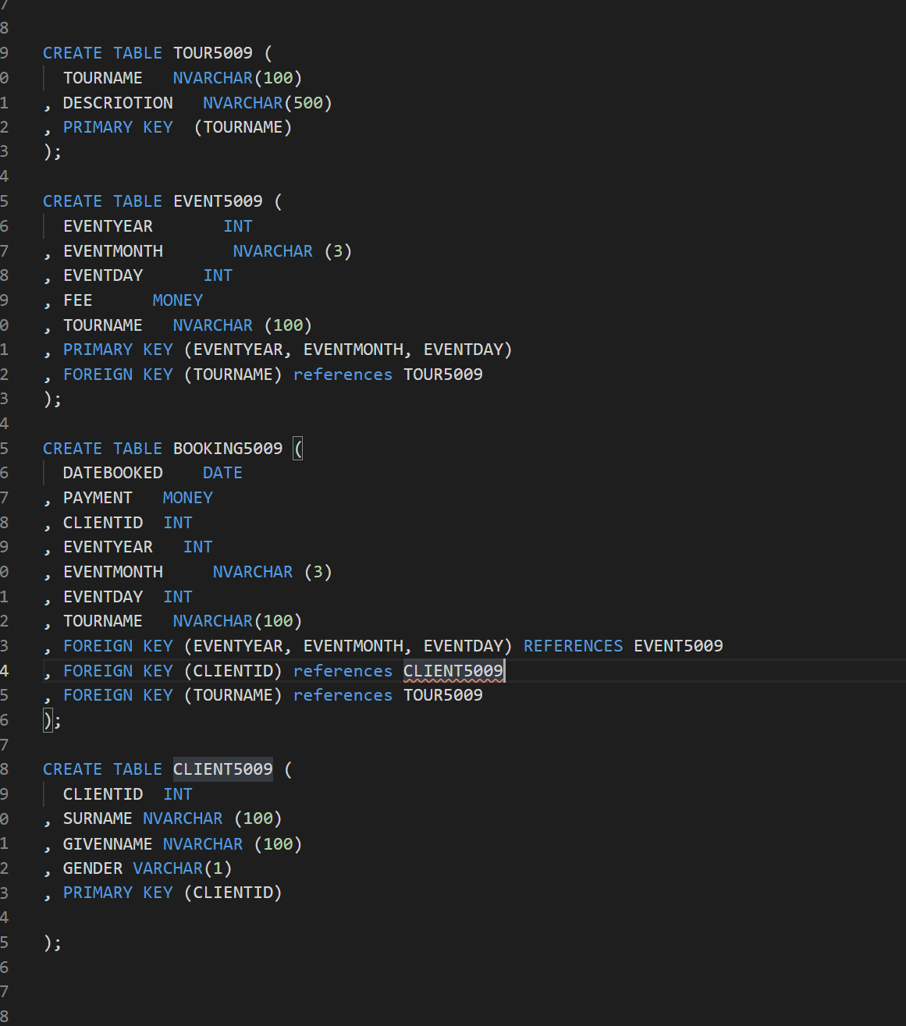

# Task 2 Screenshot

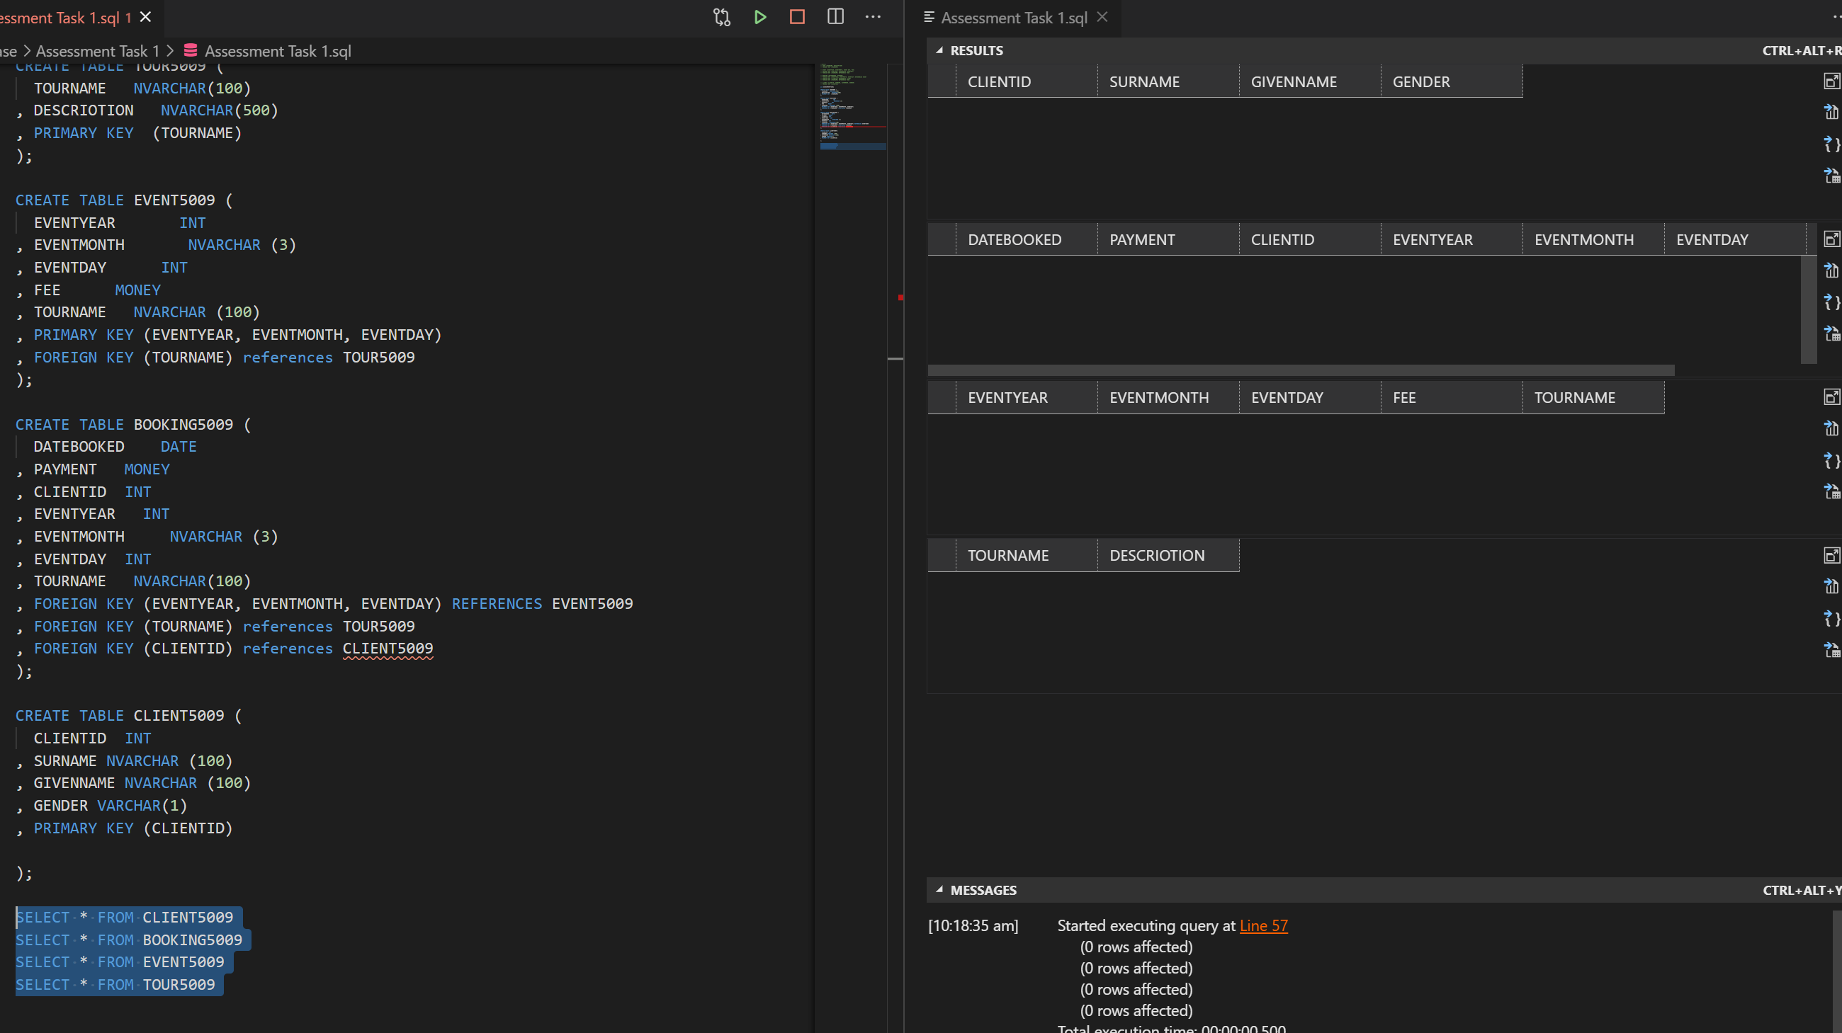

# Task 3 Screenshot

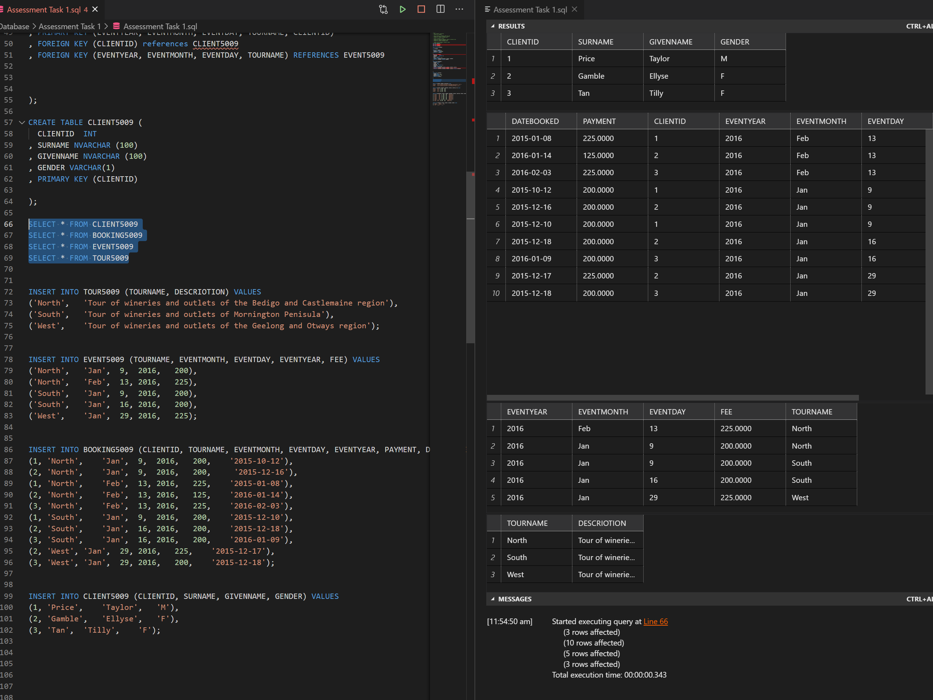

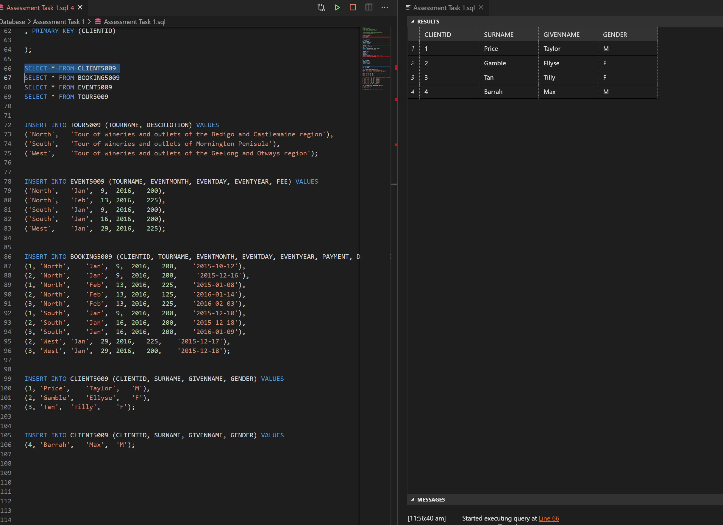

**TASK 4**

**1)**

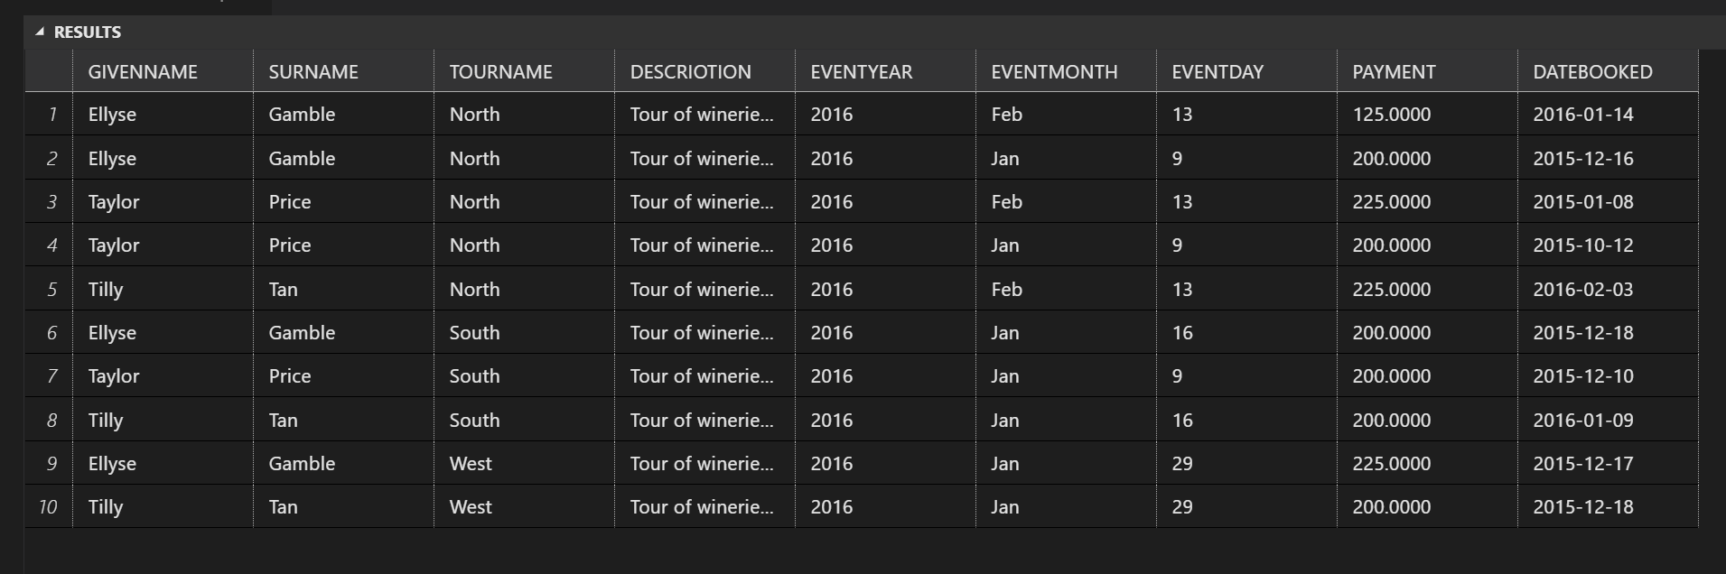

SELECT C.GIVENNAME, C.SURNAME, T.TOURNAME, T.DESCRIOTION, B.EVENTYEAR, B.EVENTMONTH, B.EVENTDAY, B.PAYMENT, B.DATEBOOKED

FROM TOUR5009 T

INNER JOIN BOOKING5009 B

ON T.TOURNAME = B.TOURNAME

INNER JOIN CLIENT5009 C

ON C.CLIENTID = B.CLIENTID

GROUP BY T.TOURNAME, GIVENNAME, SURNAME, DESCRIOTION, EVENTYEAR, EVENTMONTH,EVENTDAY,PAYMENT, DATEBOOKED

**2)**

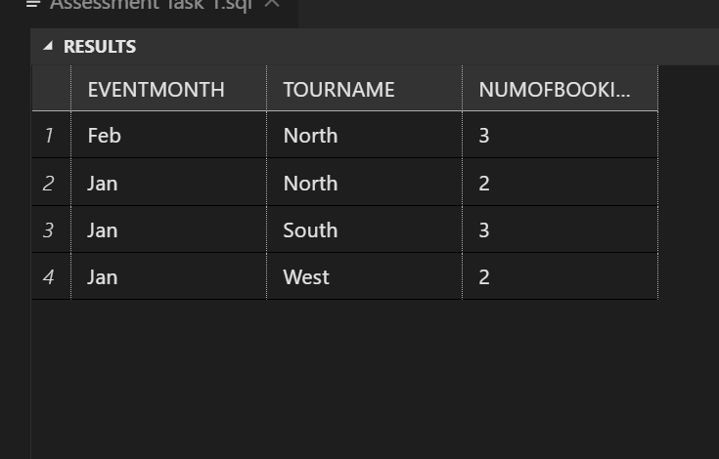

SELECT EVENTMONTH, TOURNAME, COUNT(DATEBOOKED) AS NUMOFBOOKINGS

FROM BOOKING5009

GROUP BY EVENTMONTH, TOURNAME

**3)**

SELECT * FROM BOOKING5009

 WHERE PAYMENT > (SELECT AVG(PAYMENT) FROM BOOKING5009);

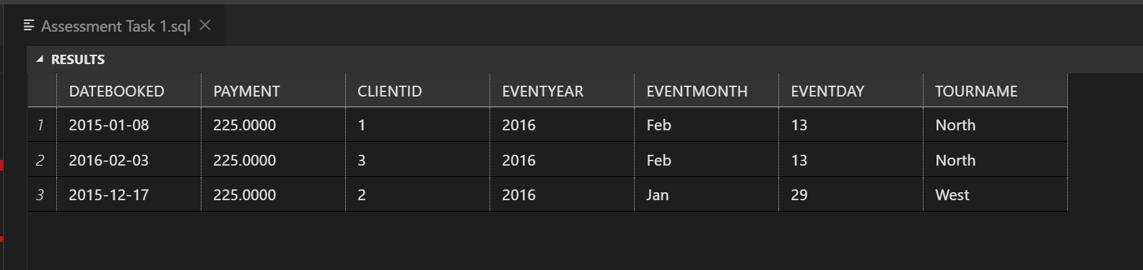

**TASK 6**

I have run test queries to ensure the data is working by firstly selecting to view all columns in a table. All tables displayed correct column names and data. I also ran the count queries on all tables with a few columns to make sure the count function was working correctly. I did this so I could cross reference what I am counting as appose to the SQL query as I am working with small amounts of data.